**TAFA/THA/THR L4**

INBOUND TOURISM GROUPS



INBOUND TOURISM GROUPS

TAFA/THA/THR: New Zealand Certificate in Tourism Level 4

STUDENT WORKBOOK



© Copyright 2017 New Zealand School of Tourism Ltd.

These notes have been prepared especially for the students of New Zealand School of Tourism. All rights reserved. This publication constitutes intellectual property of New Zealand School of Tourism. This workbook is copyright. No part may be reproduced, stored in a retrieval system, or transmitted, in any form or by any other means, electronic, mechanical, photocopying, recording or otherwise without permission. Inquiries should be made to Head Office.

COMPONENT 1: NEW ZEALAND TOURISM DESTINATIONS AND INBOUND TOURISM

MODULE: INBOUND TOURISM GROUPS

CREDITS: 7

LEVEL: 4

|  |  |  |
| --- | --- | --- |
| Graduate profile 1 | Learning Outcomes | AssESSMENT |
| Implement customer service and information advice, applying appropriate communication, literacy, numeracy and problem solving skills, to enhance the visitor experience. | Students will apply their knowledge of New Zealand tourist destinations to produce a group tour that is relevant to visitors | **TAFA/THA/THR Inbound Tourism Groups**  Itinerary and quotation for a group tour using numeracy skills, destinational knowledge and a business process.  **Task One**  Apply in-depth knowledge of New Zealand as a tourism destination (GP3).  Creating a group tour itinerary (using business systems and processes), resulting in an itinerary which will deliver a quality visitor experience. (GP4).  **Task Two**  Group pricing. Demonstrate numeracy skills by providing a group quote of the itinerary. (GP1).  (Cr7) |
| Graduate profile 3 |
| Apply in-depth knowledge of New Zealand tourism destinations in terms of characteristics, history, and attributes relevant to visitors to enhance the visitor experience. |
| Graduate profile 4 |
| Identify and evaluate tourism business systems and processes that enable the delivery of a quality visitor experience and contribute to overall business effectiveness. |

SELF DIRECTED LEARNING

STUDENT GUIDE

TAFA/THA/THR: INBOUND TOURISM GROUPS

In order for you to gain the most value from your qualification and to prepare you for your assessment and the industry, make sure you complete all of the tasks below.

Monday to Thursday

Complete the Industry Calculations module in Moodle

This is located in THA Self-Directed Learning Guide under Literacy & Numeracy. Each morning there will be a brief class discussion on your progress.

In Moodle, in the THA/THACE/TAFA Self-Directed Learning guide, is access to

The ‘RTO Tourist Regions of NZ’ quiz. Your challenge is to correctly allocate

all **31** regions, correctly, closed book. This will ensure you have a full

understanding of how domestic tour itinerary’s need to geographically flow

through a region and throughout NZ. You may try as many time as you wish.

Complete the recap Moodle quiz in the THA Self Directed

Learning Guide – Inbound Tourism, each evening.

Your aim is to get 100%, you can keep trying.

My mark is ____________%

Continue to work on your group tour itinerary *and* marketing material.

**Any additional assigned tasks/work your trainer has set you.**

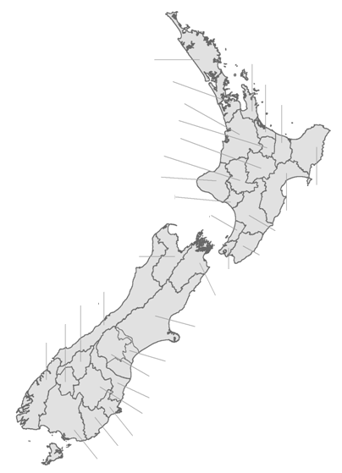

table of contents

INTRODUCTION 1

INBOUND TOUR OPERATOR 2

contiki holidays 3

DESIGNING YOUR ITINERARY 8

daily summary 9

logical cohesive & managable 10

ITINERARY SECTORS 12

NORTH ISLAND itinerary SECTors 13

SOUTH ISLAND itinerary sectors 15

JOINING THE SECTORS TOGETHER 17

Transportation 20

Activities & Attractions 21

Accommodation 22

nightly room rates 24

SEASONALITY 26

room occupancy & ‘extra person’ rates 26

inclusions 28

Meals 30

free time 31

explore your touring options 32

POTENTIAL activities & attractions 33

special meal options 36

possible tour route 38

Accommodation options 40

first draft of your itinerary 43

constructing the group tour cost 46

Estimated Tour Cost 46

Mark Up 47

final itinerary 51

actual selling price 55

promoting your tour 57

brochure 57

daily summary of itinerary 60

name of your tour **Error! Bookmark not defined.**

name of TOUR COMPANY 67

designing & producing promotional material 69

QUALITY CONTROL 76

the final product 77

presenting your tour itinerary 77

FINAL ADVERTISED SELLING PRICE 77

kiwi potluck lunch 80

INTRODUCTION

Inbound tourism is when international visitors travel to New Zealand usually for the purpose of a holiday. Inbound tourists wants to see and experience as much as they can during their travels.

There are various ways which our international visitors can see New Zealand, some prefer to go at it on their own and book arrangements themselves, they are called FIT – free independent travellers. While some prefer to do a group tour, and it is the ‘inbound tour operators’ which provide this option for international visitors.



Why might some international visitors prefer to do a tour of New Zealand rather than be a FIT?

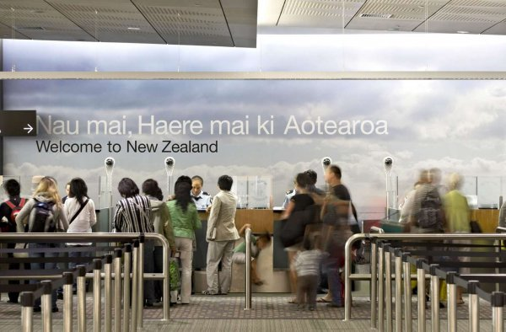

INBOUND TOUR OPERATOR

An inbound tour operator promotes and sells New Zealand packages and tours to international buyers such as wholesalers, travel agencies and event planners.

Inbound tour operators provide a critical link between the suppliers of New Zealand tourism products and the overseas travel companies which purchase the packages and tours and sell them onto their clients.

Here are some of the inbound tour operators which promote their tours to overseas buyers and operate in New Zealand:

* Contiki Holidays
* APT Group
* AAT Kings Tours
* Kirra Tours
* Tourmasters South Pacific
* Pan Pacific Travel
* Magnetic South
* Leisure Time Tours
* Kiwi Holidays Ltd
* China Travel Service (NZ) Ltd

All of these operators cater for the inbound tourism market, i.e. international visitors to New Zealand.

Each inbound tour operator designs and promotes various tour itineraries to meet the needs and wants of our international visitors. Some operators focus on a specific target market, i.e. Contiki Holidays cater for 18-35yr olds, China Travel Service (NZ) Ltd cater for Chinese visitors coming to New Zealand – while others may cater for a wider audience.

Each inbound tour operator works with individual tourism operators, striking deals to include their specific tourism product/s into their tour itinerary. These products may include accommodation, activities, attractions, transportation, events, meals etc.

The inbound tour operator will design an amazing tour itinerary which includes the various tourism products, which they will then promote and sell to the overseas market.

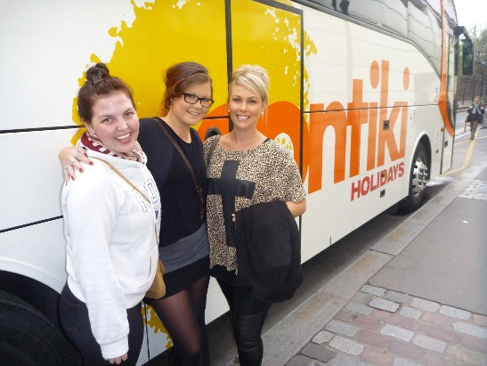contiki holidays

Contiki Holidays is an international touring company which offer tours in many regions of the world, of varying standards, durations and inclusions. Contiki cater for the younger demographic of 18-35yr olds.

Play the video clip:

CONTIKI – NADINE’S NEW ZEALAND ADVENTURE



Refer to your extracts and let’s take a look at one of Contiki’s New Zealand touring itineraries which is currently promoted and sold to inbound tourists (international visitors to New Zealand) – The Big Tiki.

**THE BIG TIKI**

1. What is the duration of this tour?
2. What is the per person tour cost?
3. All tour operator allocate a ‘tour code’ to each of their itineraries. Explain the reasoning behind this.
4. The Big Tiki tour actually has two different ‘tour codes’. Explain why this is.
5. Look over the entire two pages which Contiki has used to present this tour to potential clients. Look at the format and design of the pages, look at what type of information has been included and how it has been presented. Discuss with a partner, what Contiki have done to promote and sell this tour.
6. 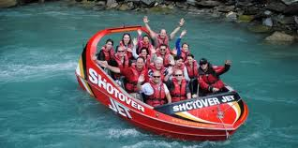Identify all the ‘adventure’ activities which are included or offered as an optional extra in this itinerary.



1. 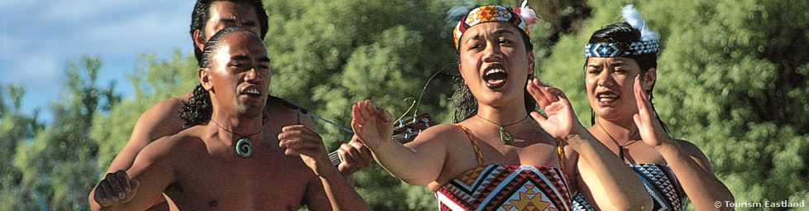Identify all the ‘cultural’ activities and attractions which are included or offered as an optional extra in this itinerary.
2. 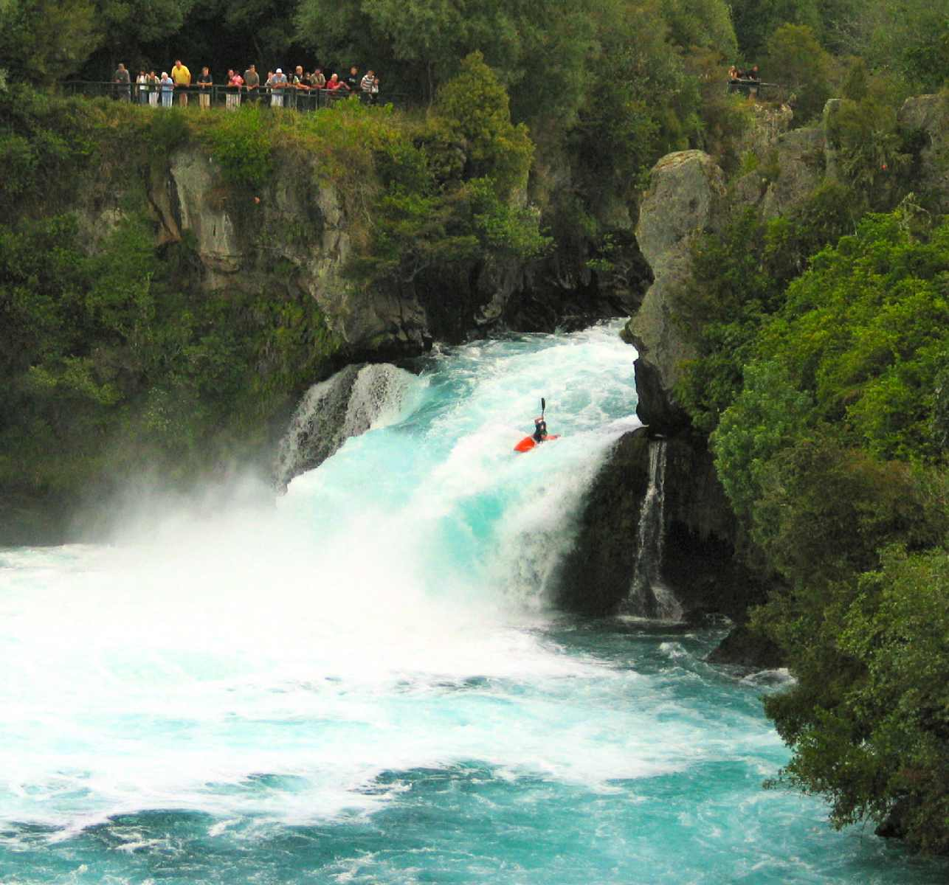Identify all the ‘eco-tourism’ activities and attractions which are included or offered as an optional extra in this itinerary.
3. List all the ‘optional activities’ that Contiki offer during this tour.
4. Why do you think Contiki has included all of these activities and attractions in this itinerary?

DESIGNING YOUR ITINERARY

Your assessment task is to create a group tour itinerary based around a specific region of New Zealand. Your trainer will hand out your assessment paper so you can review the criteria and the requirements.

**Your tour ITINERARY must include:**

* 16 paying clients
* Duration of 5 days of touring
* 3 Attractions
* 3 Activities
* 5 nights accommodation*
* Luxury coach transportation
* Some meals

Each student will design a 5 day itinerary based on a different region of New Zealand.

Ultimately, each itinerary will be put together to create an entire New Zealand tour covering most of the country.

*\*NOTE: The 5th night of accommodation is purely required so that the group are positioned in the location which the next itinerary sector begins. This is explained in more detail further on in the workbook.*

If this was a real tour that was being promoted and sold to international visitors, those visitors would have a variety of touring options available.

They could choose to do the entire New Zealand tour, or the whole of the South Island, or perhaps just one section, for example the Northland tour.

**ALSO:**

You need to come up with catchy name for your tour, one which fits and represents your region and tour itinerary. It’s probably better to leave this part till later, so you can get a better feel for your tour as you’ll know what’s included in your tour itinerary, which will help with coming up with a tour name.

Once you have finished designing your tour, and have finalised the inclusions, and written the paragraphs summarising each day of the itinerary, you need to create an A3-sized, landscape orientation page, to promote your tour. This page will be collated together with the other student’s pages to create an A3-sized brochure.

You are not required to plan your itinerary down to the minute or even the hour. Your main focus is to design a fantastic and exciting itinerary which includes all the best New Zealand has to offer.

daily summary

Once you have worked out the details of your itinerary, i.e. the route for each day, what you will include on each day etc. Rather than writing out a detailed itinerary, you need to write an exciting and informative paragraph which briefly explains what each day will include.

The main highlights of your tour must be highlighted in the itinerary, within the daily summary.

Below is an extracts from the ‘The Big Tiki’ Contiki tour and look at how they have summarised their daily itinerary.

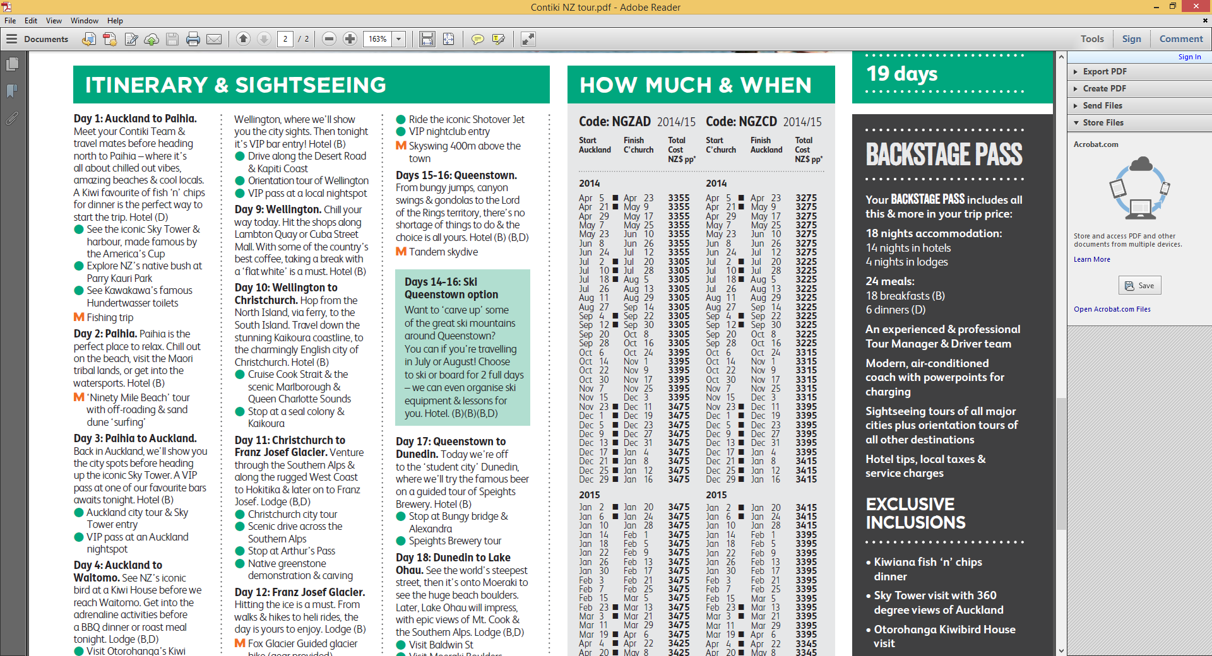For your tour, you will write more than what Conitki has to explain each day of the itinerary. You tour will have only 5 days of touring to summarise, while Contiki had almost 20 days, hence the short summaries.

logical cohesive & managable

You need to ensure that your itinerary is logical, cohesive and manageable. This means that your itinerary needs to flow in a logical order correctly and is actually do-able.



Read over the following summary of a day in a Northland tour itinerary. Decide whether or not this is an example of a logical, cohesive and manageable daily plan. Explain your answer.

***DAY 1***

*“Depart Paihia for Cape Reinga for a morning of discovery and experience Ninety Mile Beach by 4WD Safari. In the afternoon, enjoy exhilarating ‘sand surfing’ at Hokianga, then surround yourself in the ancient and magnificent Waipoua Forest where you will be in awe of the ‘Lord of the Forest’ Tane Mahuta. Finally, a visit to the award-winning winery – Okahu Estate in Kaitaia before arriving in New Zealand’s biggest city, Auckland. Accommodation: Novotel Hamilton Tainui.”*

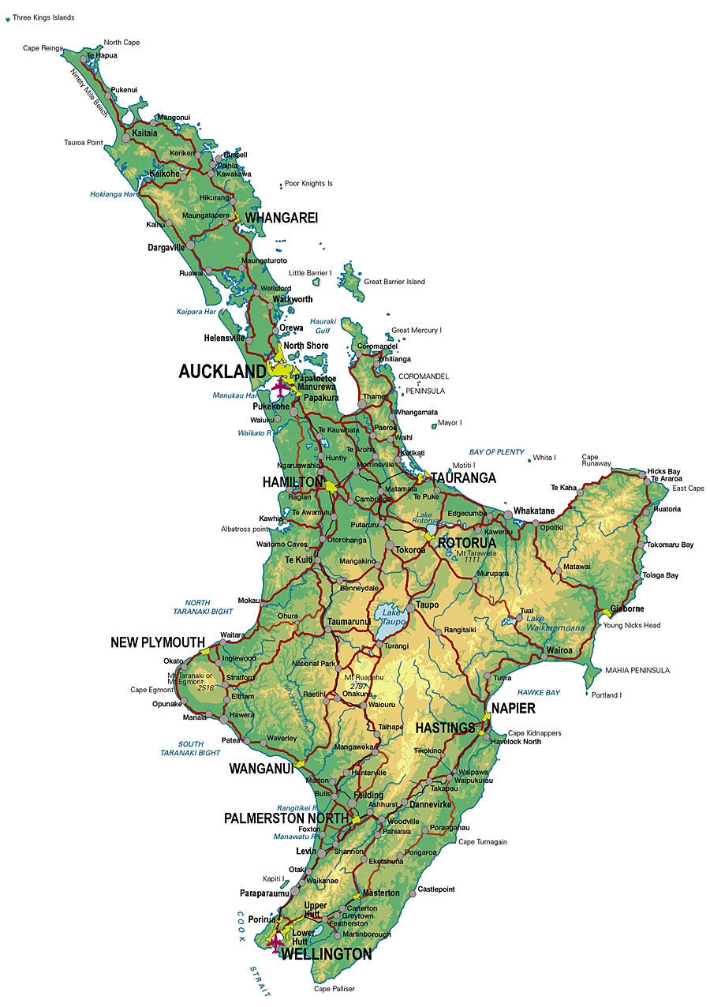

**ASPECTS TO BE AWARE OF:**

* The travel distances are manageable, i.e. your itinerary doesn’t travel from Picton to Queenstown in one day.
* Your itinerary flows in a logical order.
* The attractions/activities included are correct and fit within the given itinerary, i.e. the Sky Tower is included as an attraction in an Auckland itinerary, and not within a Rotorua itinerary.
* The accommodation included is correct and fits within the given itinerary, i.e. DeBretts Spa Resort is included as an accommodation provider in a Taupo itinerary, and not within an Auckland itinerary.

ITINERARY SECTORS

Each student will create a 5 night itinerary for a different region of New Zealand. Ultimately, these individual itinerary sectors will join up to create one whole New Zealand tour itinerary.

The itinerary sectors are set, including the start & finish points of the tour. Each student will work on designing an exciting tour based around a specific itinerary sector which will be allocated out.

The reason the itinerary sectors have been ‘set’ is so that they can all join up with each other to create a New Zealand wide tour.

NORTH ISLAND itinerary SECTors

There are 20 itinerary sectors in total: 10 in the North Island and 10 in the South Island.

On the following page is a map of the North Island which shows the general area for each sector listed below.

* + Sector 6

**ROTORUA**

START: Rotorua

FINISH: Taupo

* + Sector 7

**LAKE TAUPO/RUAPEHU**

START: Taupo

FINISH: Napier

* + Sector 8

**HAWKES BAY/GISBORNE**

START: Napier

FINISH: Napier

* + Sector 9

**WAIRARAPA**

START: Napier

FINISH: Martinborough

* + Sector 10

**WELLINGTON**

START: Martinborough

FINISH: Picton (overnight ferry crossing)

* + Sector 1

**NORTHLAND**

START: Paihia

FINISH: Auckland City

* + Sector 2

**AUCKLAND**

START: Auckland City

FINISH: Thames

* + Sector 3

**COROMANDEL**

START: Thames

FINISH: Hamilton

* + Sector 4

**WAIKATO/KING COUNTRY**

START: Hamilton

FINISH: Tauranga

* + Sector 5

**BAY OF PLENTY**

START: Tauranga

FINISH: Rotorua



Label each of the 10 itinerary sectors for the North Island, on the map which follows.



SOUTH ISLAND itinerary sectors

* + Sector 16

**LAKE WANAKA**

START: Haast

FINISH: Queenstown

* + Sector 17

**QUEENSTOWN**

START: Queenstown

FINISH: Te Anau

* + Sector 18

**FIORDLAND/SOUTHLAND**

START: Te Anau

FINISH: Dunedin

* + Sector 19

**OTAGO/**

**SOUTH CANTERBURY**

START: Dunedin

FINISH: Oamaru

* + Sector 20

**MACKENZIE/**

**MT COOK (AORAKI**)

START: Oamaru

FINISH: Christchurch

* + Sector 11

**NELSON/TASMAN**

START: Picton

FINISH: Nelson

* + Sector 12

**MARLBOROUGH**

START: Nelson

FINISH: Blenheim

* + Sector 13

**KAIKOURA / NORTH CANTERBURY**

START: Blenheim

FINISH: Christchurch

* + Sector 14

**CHRISTCHURCH /**

**CENTRAL CANTERBURY**

START: Christchurch

FINISH: Greymouth

* + Sector 15

**WEST COAST**

START: Greymouth

FINISH: Haast



Label each of the 10 itinerary sectors for the South Island, on the map which follows.

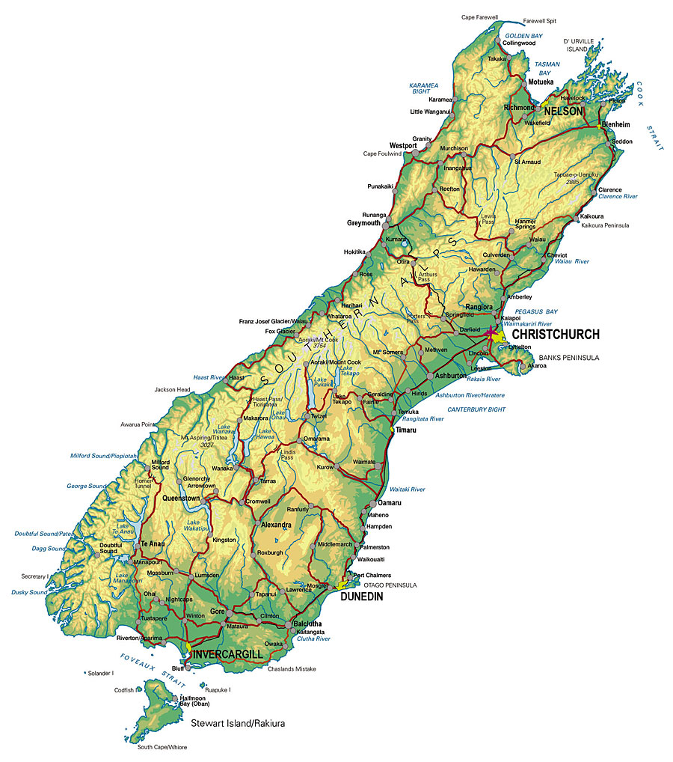

JOINING THE SECTORS TOGETHER

Let take a look at how you need to structure your itineraries in terms of the START (day 1) & FINISH (day 5), so that it joins up with the other itinerary sectors.

Here are the first 2 itinerary sectors; how do we ensure that these will join up with each other?

Sector 1

**NORTHLAND**

***This itinerary sector will focus on the Northland region.***

START: Paihia

FINISH: Auckland City

**DAY 1**

Starting point is Paihia. The group will meet at a specified meeting point (which is usually the lobby of the hotel which the group will be staying at for the first night of the tour).

**DAY 2, 3 & 4**

No special instructions.

**DAY 5**

This is the final day of the itinerary, and for this particular itinerary, the finishing point is Auckland City.

This means that the group must eventually end up in Auckland and stay overnight (5th night of accommodation), so when they wake up the next day, they will already be in position to start the next sector; in this case the next sector begins in Auckland.

It’s important to note that DAY 5 of the itinerary doesn’t include any Auckland activities, because the group will experience the Auckland region in the next sector.

Sector 2

**AUCKLAND**

***This itinerary sector will focus on the Auckland region.***

START: Auckland City

FINISH: Thames

**DAY 1**

Starting point is Auckland. The group will already be at the starting point because the preceding itinerary sector overnighted the group in Auckland.

**DAY 2, 3 & 4**

No special instructions.

**DAY 5**

This is the final day of the itinerary, and for this particular itinerary, the finishing point is Thames.

This means that the group must eventually end up in Thames and stay overnight (5th night of accommodation), so when they wake up the next day, they will already be in position to start the next sector; in this case the next sector begins in Thames.

It’s important to note that DAY 5 of the itinerary doesn’t include any Thames (Coromandel) activities, because the group will experience the Coromandel region in the next sector.

1. 

Explain the next two itinerary sectors (3 & 4) for the North Island, and discuss how they will join up with the previous Auckland itinerary, and the next itineraries that follows.

**Sector 3**

**COROMANDEL**

***This itinerary sector will focus on the Coromandel region.***

DAY 1 - START: Thames

DAY 5 - FINISH: Hamilton

**Sector 4**

**WAIKATO/KING COUNTRY**

***This itinerary sector will focus on the Bay of Plenty region.***

DAY 1 - START: Hamilton

DAY 5 - FINISH: Tauranga

Let’s take a look at the components that are typically included within a group tour itinerary. To simplify things, some of the following tour components have already been worked out for you, and therefore every student will use the same outline and information as shown in the workbook.

Transportation

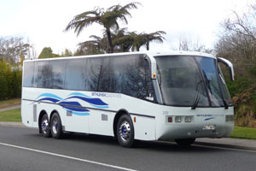Inbound tour operators need to consider the type of transportation to include for the tour and whether it matches their clients’ needs.

Transportation might be needed for:

* Getting to the destination by plane/train/coach
* Airport to hotel transfers
* Transfers to an event and/or attraction

**FOR THE PURPOSES OF THIS MODULE (& ASSESSMENT)** you will use deluxe coach transportation throughout your tour itinerary.

Deluxe Coach Vehicle

*20-seater vehicle. Suitable for short and long distance travel, the deluxe coaches feature air conditioning, individual air vents, reading lights, TV, DVD/CD player, PA system, radio, reclining seats, large luggage space and some come equipped with restrooms. Deluxe coaches also feature ABS braking, power steering and air suspension for a smoother journey.*

**Flat rate of $450.00 per day –** which will include the cost of accommodation and meals for the tour guide/driver.

**WORKING OUT THE COSTING**

To work out the person costings for transportation, you need to calculate the total cost of the coach transportation, then divide it by the number of ‘paying clients’ on the tour.



Work out the person cost for transportation using the flat rate shown above.

*Remember this price covers the cost of the tour guide/driver’s accommodation and meals – so you don’t have to worry about trying to it work out and spread it over the tour.*

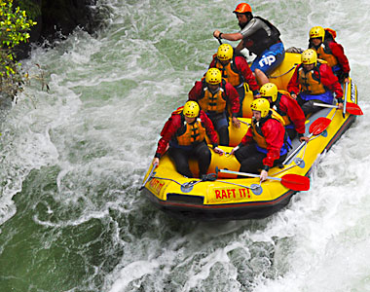Activities & Attractions

It is up to you which activities and attractions you choose to include in your group tour itinerary.

You should include activities and attractions which are unique and special to New Zealand, i.e. adventure, cultural, eco-tourism or special interest-based, such as food and wine, cycling, film tourism etc.

You can include them in the cost of your tour or as an optional extra, but remember your tour could be more appealing if the sightseeing is already included in the cost.

If the attraction you wish to include has an entrance fee, this should also be included in the cost. Be careful if your sightseeing attractions are weather dependent, you will need to have an alternative option available.

**FOR THE PURPOSES OF** **THIS MODULE (& ASSESSMENT)**

Your group tour itinerary must include at least:

* 3 attractions

* 3 activities

All 6 activities/attractions must be included in your group costing.

You may also include additional activities/attractions, which you can either include in your group costing, or as an optional extra.

**WORKING OUT THE COSTING**

Working out the costings for the activities and attractions component is fairly easy because all operators will list ‘per person’ prices.

If you decide to include ‘optional extras/activities’ make sure you do not factor these into your main group costing.

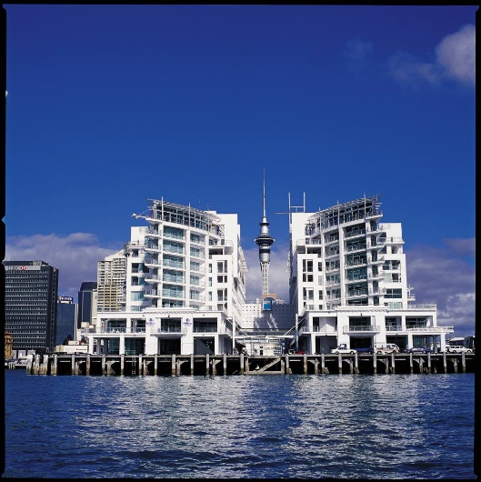Accommodation

For your group tour itinerary, you must include accommodation for all five nights. It is up to you which accommodation properties you include within the tour; however you need to think about

* the standard
* the location
* services and facilities
* room types
* overall capacity –the property must have the capacity to sleep 17 pax (e.g. 8x twin-share rooms, plus 1x single room)

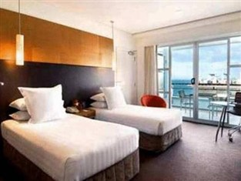Depending on the specific region and route you are allocated to build your touring itinerary around – you might include 5x different accommodation properties, i.e. 1x night at each property. Or perhaps you might only use one property for the entire itinerary, i.e. if your tour is based within a small region such as Rotorua.

**FOR THE PURPOSES OF** **THIS MODULE (& ASSESSMENT)** you can use a variety of accommodation types, however you need to ensure that the accommodation you choose meets the needs and wants of tour participants.

STANDARD OF ACCOMMODATION REQUIRED

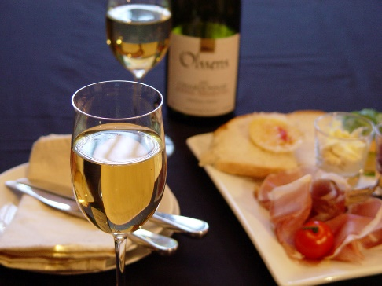You need to include properties of at least a 3 star rating (or the equivalent to). This means you can also include 4 or 5 star accommodation in your itinerary as well, for example; you might like to include a special night in your itinerary to wow your group, e.g. Tongariro Chateau.

You must include **FIVE NIGHTS ACCOMMODATION**.

For each night of your itinerary, your tour group requires the following accommodations:

**\* 8 twin-share rooms (*8 rooms x 2 guests in each room = 16 guests)**

***PER PERSON / PER NIGHT COST*** *will differ depending on the accommodation properties you choose to include in your itinerary.*

1. 

What type of accommodation could be used in your tour itinerary? Remember that you require accommodation for 17 pax (including the tour guide).

**WORKING OUT THE COSTINGS**

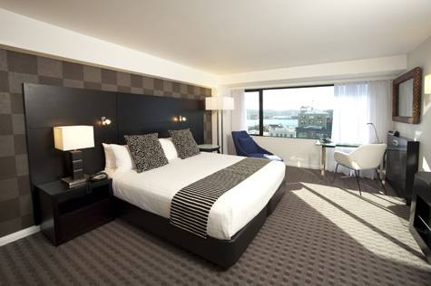It’s important to understand how to work out the cost of accommodation, sometimes it can be tricky because not all hotels display costings in the same way; some use a ‘per person, per night’ costing, while others use a ‘per room, per night’ costing.

It’s really important that you recognise and understand how the costings are displayed, and how to work out the correct cost.

If you misunderstood how the costs work, and you underestimated your total accommodation costs, you will be in trouble as your financials for your group tour would be way out and you would most likely make a loss.

The vital aspects of accommodation costings that you need to be aware of are:

* Nightly room rate (per room OR per person)
* Seasonality
* Maximum occupancy and ‘extra person’ rate
* Inclusions

nightly room rates

For example: You need 5x twin-share rooms to accommodate 10 people. You factor the costing into your itinerary - $95.00 per room, per night. In actual fact the correct costing is $95 per person, per night.

If this example were true and you factored in the incorrect costing into your group itinerary, you would make a tremendous loss.



Let’s find out how significant an accommodation costing error can be. You need to work out the cost of accommodation for 5x twin-share rooms (2x adults per room) for 5 nights.

1. $95.00 per room, per night
2. $95 per person, per night
3. If you actually made this mistake, work out how much this error would cost you.

Hilton Auckland

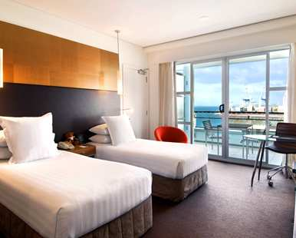**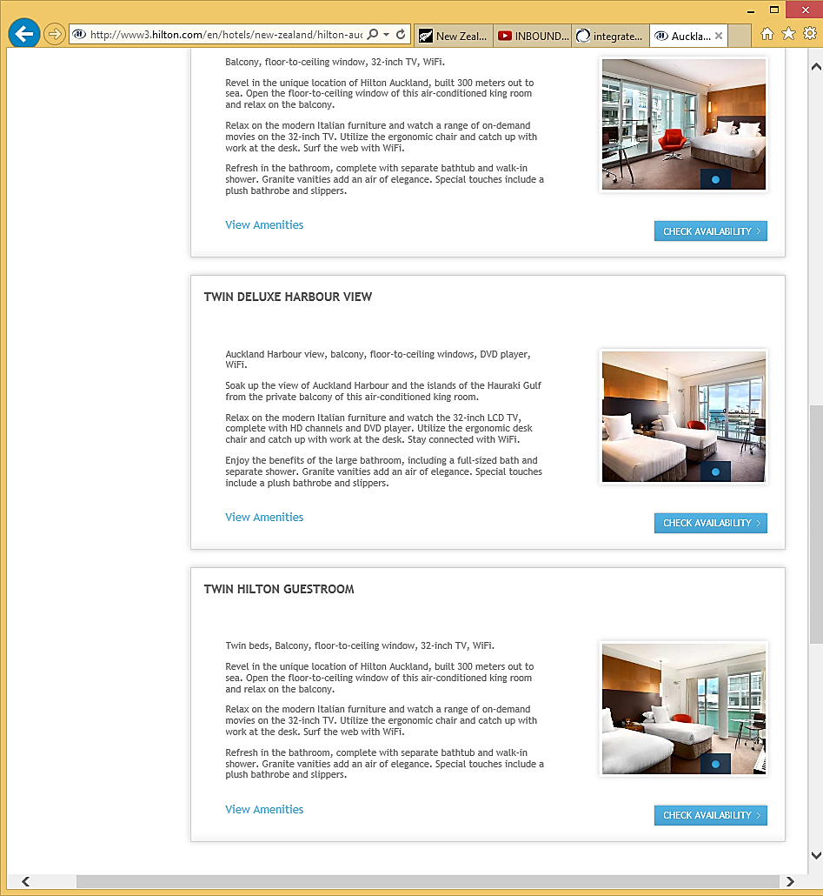Twin Deluxe Harbour View**

**$423.00 per night** (including breakfast)

*Max 2 adults per room*



Imagine you are including the Hilton Hotel in Auckland as part of your itinerary. Work out the accommodation costs for 5x twin-share rooms   
(2 adults per room) for 5 nights.

SEASONALITY

Most hotels adjust their rates for different times of the year – this is referred to as ‘seasonality’ - i.e. ‘high / shoulder/ low seasons’. Hoteliers will take advantage of the most popular times which accommodation is sought, and will increase their rates accordingly.

In the extract below, you’ll see that two properties featured each display their own seasonality dates and for each room type displayed by the two properties, there is a different nightly rate depending on which ‘season’ the booking is made within.

room occupancy & ‘extra person’ rates

The rates displayed by each property are also based on a certain number of people staying in the room. This is because of the bedding configuration within the room, everyone who stays in the room must have a bed to sleep on.

In the extract below, it states the occupancy per room, which the rates are based on, i.e. Studio room rate is based on 2 people.

Extra person rates are generally used when additional bedding needs to be brought into the room, i.e. a rollaway bed.

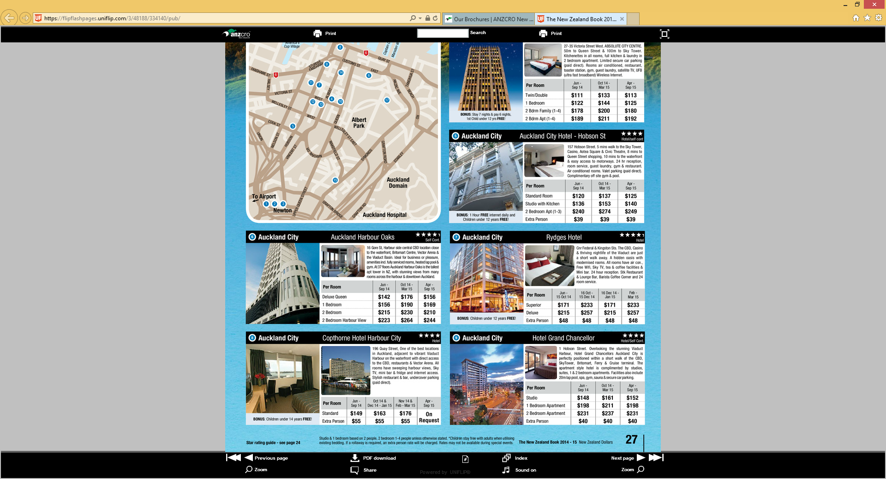

*NOTE: Studio & 1 bedroom based on 2 people, 2-bedroom based on 1-4 people unless otherwise stated and when using existing bedding. If a rollaway is required, an ‘extra person’ rate will be charged.*

1. 

Using the extract on the previous page, work out the total accommodation costs for the following scenarios.

Make sure you show your workings.

1. **Rydges Hotel**

*Accommodation for 20 pax*

10 Deluxe rooms (twin-share)

IN: 05OCT / OUT: 08OCT

1. **Hotel Grand Chancellor**

*Accommodation for 8 pax*

2 x Two bedroom apartments (for 4 people)

IN: 16JUL / OUT 21JUL

1. **Hotel Grand Chancellor**

*Accommodation for 12 pax*

2 Single rooms

5 Twin-share rooms

IN: 21NOV / OUT: 27NOV

inclusions

There are other things which you must be aware of as well, when costing up the accommodation.

Hotels tend to offer various prices for the same room type and the reason for this is because they may have varying inclusions and impose differing terms and conditions.

So you must be very aware of what the rate actually includes and what the terms and conditions are for the rate.

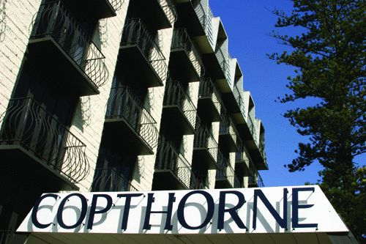

Some questions you need to think about are:

* Is it ‘room only’ cost?
* Does it include any meals, i.e. breakfast?
* Is it a ‘package’ price?
* What is the cancellation policy?
* What amenities are in the room?
* Are there any features, i.e. balcony?



On the next page is an extract from the Copthorne Auckland Harbour City Hotel, for the SUPERIOR ROOM WITH TWIN BEDS. There are three different deals on offer for the same room type.

Analyse each deal and work out which deal you think is best. Explain why you believe it is the best deal.

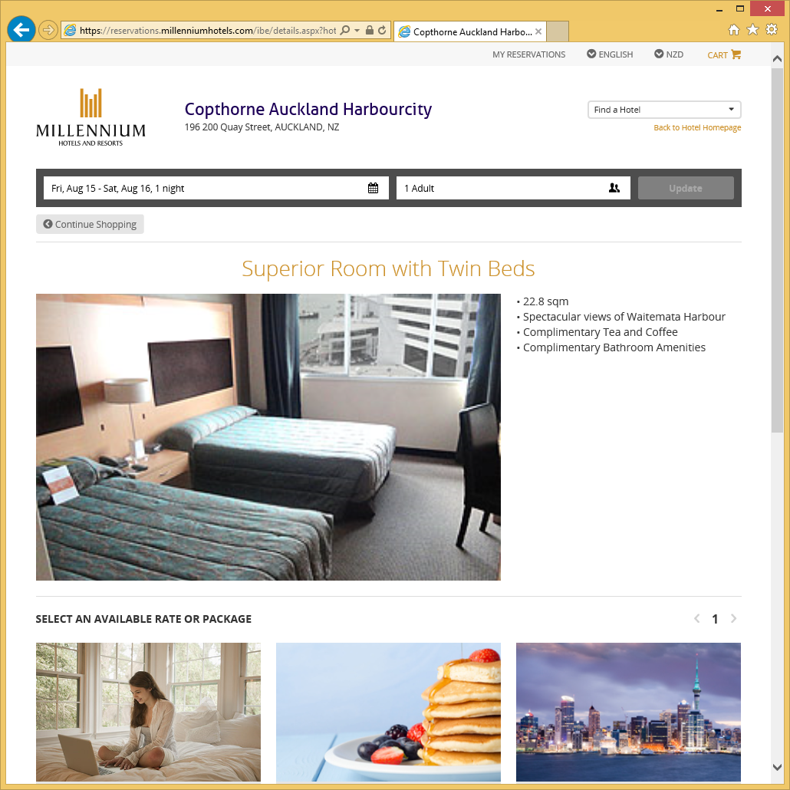*The following extracts is sourced from: www.millenniumhotels.com*

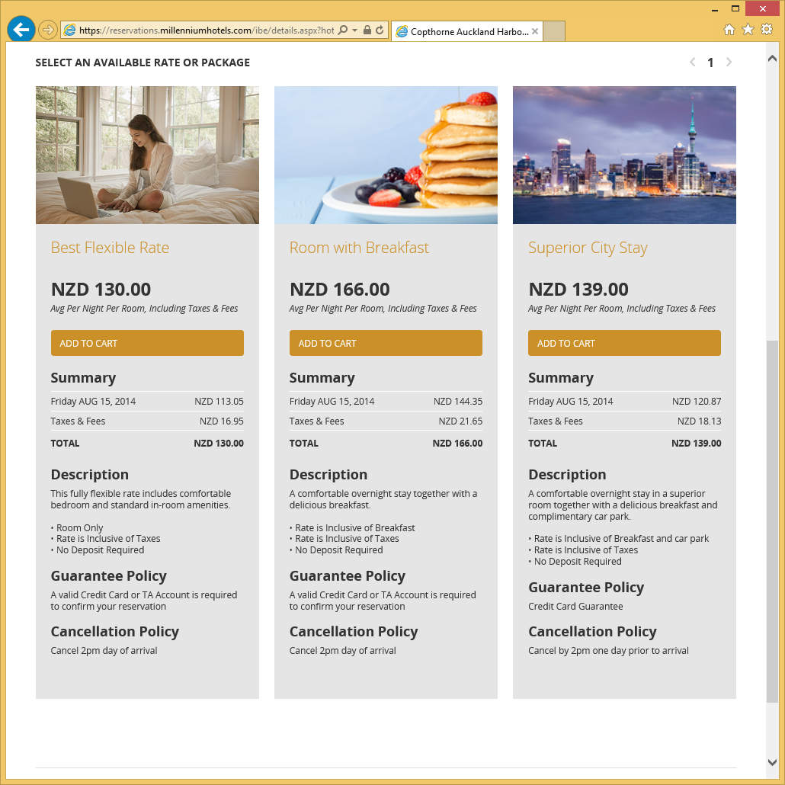

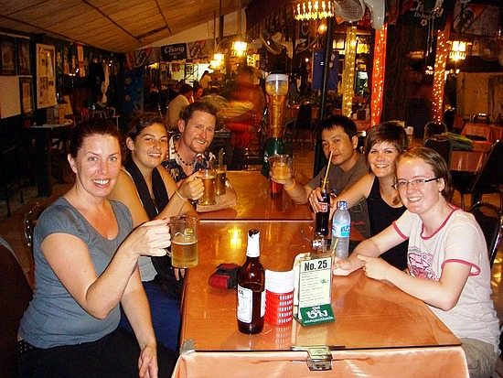Meals

Breakfast is often included in group tours, with clients making their own arrangements for lunch and dinner. Sometimes the tour operator will include some lunches and dinners as a special feature of the tour. For example: lunch at a winery.

**FOR THE PURPOSES OF** **THIS MODULE (& ASSESSMENT)** there are set meal inclusions and costs.

Your tour will include a daily breakfast, 2x special lunches and 2x special dinners.

In your itinerary you do not need to specify where breakfast will be and what it will include (you just need to include the cost of breakfast in your tour costing).

You do however need to identify where these special lunches and dinners take place during your tour and it must be somewhere which showcases New Zealand food & wine.

Some options for a special lunch/dinner may include: a winery or an award-winning restaurant, or well-known local café/restaurant etc.

In terms of the meals, use the following costings:

* 5 Daily Breakfasts @ $10pp
* 2 Special Lunches @ $35pp
* 2 Special Dinners @ $45pp



**WORKING OUT THE COSTING**

Let’s work out the per person cost for meals.

free time

It’s important that you also include some free time or down time in your tour itinerary. But bear in mind, that participants have paid to do a tour so they experience as much of the region as possible – so while it’s important to have some free time, it’s also important not to include a lot of it either.

Free time could be an entire morning or afternoon, or perhaps only a few hours during the evening, i.e. the group might return to the hotel at 5pm after an activity, and then the evening is free (and dinner own arrangements).

During the extended periods of free time, e.g. an entire morning, it’s recommended to offer an ‘optional activity’ for those who do not want to have down time or who may not feel confident to explore on their own.

It is up to where and when you include some free time during your tour itinerary.

explore your touring options

Now it’s time to get inspired and creative – start researching your region and come up with some fun and exciting possibilities of what activities and attractions you could include in your tour.

To make this easier for you, make sure that you **note down the website** of the attractions and activities which you like the look of and may include in your tour. You’ll need to refer back to the websites to get the pricing for your tour itinerary.

**RECAP:** **Your tour ITINERARY must include:**

* 16 guests
* 5 days of touring
* 5 nights accommodation (3 star plus, or equivalent)

8 twin-share rooms (16 guests in total = 2 guests sharing a room)

* 3 attractions
* 3 activities
* Coach transportation for a flat rate of $450 per day *(which includes the cost of accommodation and meals for the tour guide/driver).*

$450 x 5 days = $2,250 / 16 pax = $140.63 per person

* Meals: $210 per person. This is made up of
* 5 Daily Breakfasts @ $10pp
* 2 Special Lunches @ $35pp
* 2 Special Dinners @ $45pp

POTENTIAL activities & attractions

special meal options

You need to include **2 special lunches** and **2 special dinners** which **showcase New Zealand food and wine**. Options may include wineries, award-winning establishments, well-known local cafes or restaurants.

possible tour route

Based on your list of potential attractions & activities and special meal options, work out a possible tour route for your itinerary, bearing in mind the start/finish points for your tour.

Accommodation options

Now that you have an idea of the route you wish to take and the inclusions you would like to possibly include in your itinerary, start researching possible accommodation options for your tour.

Don’t worry too much about pricing at this stage for accommodation, except for making sure it isn’t too expensive. Remember the accommodation for your tour needs to be at least 3-star (or the equivalent of), and you can use 4 & 5 star properties as well – e.g. you might like to include one night of luxury in your itinerary.

first draft of your itinerary

Now it’s time to narrow down your options and firm up your tour itinerary route and inclusions, and this time include the pricing for the individual components – you will use these costs to construct an estimated group tour cost in the next exercise.

**DAY 1**

**DAY 2**

**DAY 3**

**DAY 4**

**DAY 5**

**ADDITIONAL NOTES**

constructing the group tour cost

When constructing a cost for your group tour, you need to base the cost on NET prices that have been provided by your suppliers. You can then ADD a MARK-UP to ensure you make a profit on each sale.

Estimated Tour Cost

Once we know all the components that are to be included in the itinerary, listed in date order, we can then construct the probable tour cost, add a mark-up, and then calculate an estimated final selling price per person and the possible profitability of the group tour.

**NET** means ________________________________________________

**MARK-UP** means ____________________________________________

**GROSS** means _______________________________________________

Therefore:

Net + Mark-up = Gross

AND

Gross - Mark-up = Net

AND

Gross - Net =Mark-up

For Example:

If the NET Value to the agent is: $798.15

And the MARK-UP is: + $100.00

Then the GROSS is: = $898.15

And the ROUNDED GROSS SELLING PRICE is: **$899.00**

Mark Up

It is up to the tour operator to decide what the mark-up will be as this is of course, how much the tour operator will actually make on each sale.

There are two methods that can be used to add a mark-up to the net price, these are:

* + A percentage (%) of the price
  + A fixed dollar ($) value (flat rate)

**FOR THE PURPOSES OF** **THIS COMPONENT (& ASSESSMENT)** we will use a

25% mark up



Let’s practice constructing a tour group costing using the following scenario. Then, you will construct the cost of your own itinerary. The ‘Swim with the Dolphins’ tour to Kaikoura from Christchurch (2 night/3 days).

You are aiming to get 40 passengers on this tour.

* Accommodation at the Lobster Inn Motor Lodge $119.00 per twin studio room.
* Charter coach with Clarks Coaches $1065.00 per day for a 40 seater coach *(this includes the accommodation and meals for the tour guide/driver)*
* Swim with the Dolphins Tour $130.00 per person
* Walking tour to the seal colony $15.00 per person
* Meals: 2x breakfasts $10pp / 3x lunches $20 / 2x dinners $35pp

Complete the table on the page, and calculate an estimated selling price for this tour.

|  |  |  |  |
| --- | --- | --- | --- |
| **ESTIMATED TOUR COSTS AND PROFITABILITY** | | | |
| **Component** | **Advertised price** | **Price per person** | |
| *Example*  *Xavier Hotel* | *$199.00 per room*  *$99.50 per person* | *$99.50* | |
| **Accommodation** |  |  | |
|  |  |  | |
| **Transportation** |  |  | |
|  |  |  | |
| **Activities/Attractions** |  |  | |
|  |  |  | |
|  |  |  | |
|  |  |  | |
| **Meals passengers** |  |  | |
|  |  |  | |
|  |  |  | |
|  |  |  | |
| **TOTAL NET PRICE PER PERSON**I | | |  |
| **PLUS MARK UP @ 25% PER PERSON** | | |  |
| **GROSS COST PER PERSON** | | |  |
| **ROUNDED GROSS SELLING PRICE PER PERSON** | | |  |
|  | | |  |
| Profit per tour: Number of people per tour ____ x mark up $_______________ | | |  |

***(This profit statement assumes that you sell all 40 tickets)***

1. 

Now work out the estimated per person costing for your own tour by completing the table below. Remember your tour is based on 16 participants. You will need to refer back to your research and/or websites used to obtain the costings.

|  |  |  |
| --- | --- | --- |
| **ESTIMATED TOUR COSTS AND PROFITABILITY** | | |
| **Component** | **Advertised price** | **Price per person** |
| TRANSPORTATION |  |  |
| ACCOMMODATION |  |  |
| ACTIVITIES / ATTRACTIONS |  |  |
| MEALS |  |  |
| **TOTAL NET PRICE PER PERSON** | |  |
| **PLUS MARK UP @ 25% PER PERSON** | |  |
| **GROSS COST PER PERSON** | |  |
| **ROUNDED GROSS SELLING PRICE PER PERSON** | |  |
| Profit per tour: Number of people per tour 16 x mark up $_______________ | |  |

final itinerary

Up to this point you have completed a lot of research on the various tourism products found in your region of New Zealand, and you have considered various possibilities in terms of what you might include in your itinerary.

Now it’s time to **finalise your tour itinerary route**, inclusions and pricing.

This is the point in time when you can make any changes to the itinerary, e.g. add/remove activities and attractions, change the accommodation, alter the route etc.

Once you have nailed down your final itinerary, you need to work out the actual tour cost and selling price, which will be done in the next exercise.



Use the pages that follow to finalise your itinerary route and inclusions.

**DAY 1**

**DAY 2**

**DAY 3**

**DAY 4**

**DAY 5**

**ADDITIONAL NOTES**

actual selling price



You already made initial calculations to estimate the tour cost and now you now need to finalise the SELLING PRICE.   
**Summarise the NET cost per person for each component:**

|  |  |  |
| --- | --- | --- |
| **ACTUAL TOUR COST & SELLING PRICE** | |  |
| **Component** | **Costings** | **Per Person** |
| TRANSPORTATION |  |  |
| Accommodation |  |  |
| Activities / Attractions |  |  |
| MEALS |  |  |
| Total tour cost (NET) Per Person |  |  |
| Mark Up @ 25% Per Person |  |  |
| Total cost (GROSS) Per Person |  |  |
| ADVERTISED SELLING PRICE Per Person |  |  |

promoting your tour

Now that you have your itinerary finalised and your selling price confirmed, you need to go about designing promotional material to promote and sell your tour.

brochure

To promote your tour, you will design and produce an A3-sized page which will ultimately become part of a full touring brochure of New Zealand.

FORMAT & STYLE

It is time to think about the design of your promotional material. This is about the way your A3 brochure page is going to look, i.e. the format and the style of it.

**The design of the overall look of your brochure page is completely up to you.**

At the end of this module, as a class you will consider and vote on the best looking page. Imagine that the class tour brochure will actually be printed and used by travel agents as a tool to promote and sell the tours.

1. 

Brainstorm the components that you need to consider in the design of your A3 brochure page.

**Written Text**

**Visuals**

**PROMOTIONAL MATERIAL CHECKLIST**

* Are photos, graphics, charts, tables, relating to the tour included?
* Is the language used clear, simple and easy to understand?
* Are the words used to describe the highlights of the tour, vivid and exciting?
* Are the visual graphics or images exciting yet appropriate?
* Is it eye-catching?
* Is there enough ‘white’ space?

*Ensure that the text doesn’t bleed out to the edges, text is easier to read if there is some plain background space surrounding it. Doesn’t actually need to be white!*

* Is the type easy to read and spaced accordingly?
* Does the material look balanced or are there too many columns, too much text, too many pictures, too much colour, different fonts?
* Did you get somebody to proof read all the material before it was produced?
* Are the images pixilated indicating they are not high enough resolution or quality?

daily summary of itinerary

Each day of you tour itinerary must be summarised into one paragraph which will feature on your A3 brochure page.

You have confirmed your tour itinerary, and now you need to summarise each day by writing an exciting and informative paragraph which briefly explains to potential participants, what is included and what they can expect to experience on each day of your tour.

You need to ensure that you emphasise the main highlights of each day, and use expressive and descriptive language to really create the sense of excitement and anticipation amongst potential participants, thus enticing them to purchase your tour.



Start writing a brief summary of each day of your tour. Begin by listing the highlights of each day, then think about some really colourful and exciting words that you could use to describe each experience (highlight).

Think about the order of the day’s events, and put everything together in one brief, cohesive and exciting paragraph to describe the experience of each day of your tour.

You do not need to finalise all five of your daily summaries now. Write a first draft for each day now, and come back to this later to firm them up before you produce your final copy of your brochure page.

**DAY 1**

**HIGHLIGHTS OF THE DAY & WORDS TO DESCRIBE EACH EXPERIENCE**

**Possible summary of day 1**

**DAY 2**

**HIGHLIGHTS OF THE DAY & WORDS TO DESCRIBE EACH EXPERIENCE**

**Possible summary of day 2**

**DAY 3**

**HIGHLIGHTS OF THE DAY & WORDS TO DESCRIBE EACH EXPERIENCE**

**Possible summary of day 3**

**DAY 4**

**HIGHLIGHTS OF THE DAY & WORDS TO DESCRIBE EACH EXPERIENCE**

**Possible summary of day 4**

**DAY 5**

**HIGHLIGHTS OF THE DAY & WORDS TO DESCRIBE EACH EXPERIENCE**

**Possible summary of day 5**

name of your tour

You need come up with a name for your tour. Think about your region and the activities and attractions you have included, and come up with something descriptive and catchy, something which fits and represents your region and tour itinerary.

Here are some examples of tour names which have been used by other tour operators:

* Rockin’ Rotorua
* The Wild West
* Bay to Bay
* Adrenalin Junkie
* Beach and Bush

Let your imagination run wild, and come up with an awesome name for your tour. Use the space below for ideas.

name of TOUR COMPANY

As a class you are creating a nationwide New Zealand tour by bringing together all of the individual itineraries. The class is the tour operator, so as a class you need to brainstorm and discuss a possible tour company name, as well as a name for the full New Zealand tour.

**The brochure front and back cover** must also be designed and produced to complete the class tour brochure.



Brainstorm possible tour company names in small groups, and share your ideas with the class. Choose 3-5 possible options, and have a class vote to determine the name of the tour company.

1. 

In in the same group, brainstorm possible names for the combined New Zealand tour itinerary, then share your ideas with the class. Choose 3-5 possible options, and have a class vote to determine the name of the New Zealand tour.

designing & producing promotional material

It is now time for you to start work on the design of your individual brochure page for your tour itinerary, taking all the previous information into consideration.

Design a draft layout of your brochure page – you can be as creative as you want! When you’re happy with your overall design, you will then need to produce the final A3 brochure page.

Make sure somebody is proof reading it for you. You can find logos and images from Google images (though these are usually low resolution, they will be OK for your training. Look for images over 300kb if possible if you are printing them).

**Before implementing the plan you need to do the following:**

Have the drafts approved by your tutor in this case to check that they are all happy with the quality and that it represents their organisations accurately. Once the final draft is complete, have it proof read by a third party with fresh eyes.

When you are developing your promotional material keep the following process in mind. It is best remembered by the acronym **“Adidas”**

**Attention** - you want your customer to notice your promotional material. You need something to catch their attention.

**Desire**– having read or seen something interesting, you want your customer to develop a desire for your product.

**Interest** – once you have captured their attention, you need to retain their interest.

**Designed-** with your audience in mind – international visitors.

**Action** – you need to stimulate them to take action, i.e. purchase the product.

**Satisfaction** – and finally you need your customer to be satisfied with the product so that they become a repeat customer, and refer other customers to you.

1. 

Use the next couple of pages to sketch a draft layout and design of your brochure page, and make any notes you wish.

**DRAFT LAYOUT OF BROCHURE PAGE**

**NOTES**

**NOTES**

1. 

Finalise your daily summaries which you will add to your brochure page which will be used to promote and sell your tour.

**DAY 1**

**DAY 2**

**DAY 3**

**DAY 4**

**DAY 5**

QUALITY CONTROL

Once you have finalised your tour itinerary, written the daily summaries, confirmed your actual selling price, you need to make sure that all the information is true and correct before producing your final brochure page.



What sort of system could you put into place to make sure everything is perfect before producing your final brochure page?

Think about what systems you could put into place to ensure all the information included in your promotional material is true and correct.

the final product

presenting your tour itinerary

Now you need to produce your final product; an A3 brochure page presenting your tour itinerary, which must include:

* Tour name
* Duration
* Selling price
* 5 day itinerary which is summarised
* Make sure your final brochure page is creative, eye-catching, exciting, informative etc.

*NOTE: A photocopy of your A3 brochure page must be attached to your assessment paper also.*

FINAL ADVERTISED SELLING PRICE

Use the table on the next couple of pages to calculate your final advertised selling price.

*NOTE: You will present your final group costing within your assessment paper.*

|  |  |  |
| --- | --- | --- |
| **FINAL / ADVERTISED SELLING PRICE** | |  |
| **Component** | **Costings** | **Per Person** |
| TRANSPORTATION  20-seater luxury coach | $450 per day x 5 days = $2,250  *$2,250.00 divide by 16 to get per person costing*  **$140.63 per person** | **$140.63 per person** |
| Accommodation |  |  |
| Activities / Attractions |  |  |
| MEALS  5 Daily Breakfasts  2 Special Lunches  2 Special Dinners | B/f: $10 x 5 = $50pp  Lunch: $35 x 2 $70pp  Dinner: $45 x 2 = $90pp  **$210 per person** | **$210 per person** |
| Total tour cost (NET) Per Person |  |  |
| Mark Up @ 25% Per Person |  |  |
| Total cost (GROSS) Per Person |  |  |
| ADVERTISED SELLING PRICE  Per Person |  |  |

kiwi potluck lunch

This is the final module within the New Zealand Tourism Destinations component. Let’s finish it off by having a good old Kiwi potluck lunch and celebrate our wonderful country of New Zealand.

